**Model Description**

This model is largely based on the pharmacodynamic and pharmacokinetic models of oxytocin and its relation to dilation shown in Gefferie et al. 2018 with the inclusion of studying T-type calcium current.

The pharmacokinetic model of oxytocin release from the hypothalamus (r(t)) is reliant on some gain based on the current dilation. This augments the baseline oxytocin release in order to give the equation:

P1 is the baseline oxytocin release rate from the hypothalamus, P2 is the gain from cervical dilation to oxytocin release rate. This is associated with oxytocin receptor density [Rezapour]

According to various studies, the steady state of oxytocin absorption/disposition is observed at 40 minutes, so the disposition rate constant (P3) was found to be 0.0693 min-1. [Lobo] Thus based on the release rate from the hypothalamus the change in mass of oxytocin becomes:

$\frac{dm}{dt}= -P_{3}m\left(t\right)+r(t)$

Using this pharmacokinetic equation, two pharmacodynamic relationships ultimately defining dilation can be derived: contraction frequency(f(t)) and amplitude (a(t)). The equations are reliant on the slope of the relationship, in this case a sigmoidal, P7 = 1.11, maximal contraction amplitude, P9=40 mmHg, baseline contraction amplitude, P8=40 mmHg, half max oxytocin concentration, P6 = 7.9 mU/mL and maximal concentration frequency, P5 = 0.5 1/min.

$f\left(t\right)=P_{5}\frac{{\frac{m\left(t\right)}{P_{4}}}^{P_{7}}}{{P_{6}}^{P_{7}}+{\frac{m\left(t\right)}{P_{4}}}^{P_{7}}}$

$a\left(t\right)=P_{8}+P_{9}\frac{{\frac{m(t)}{P_{4}}}^{P_{7}}}{{P_{6}}^{P_{7}}+{\frac{m(t)}{P_{4}}}^{P_{7}}}$

These equations can then be combined with fixed cervix pressure, P10 =1*10-3 cm/min, as well as the dilation increase due to contraction frequency, P11=1.9*10-2 cm/mmHg, to get the final dilation equation:

$\frac{dD}{dt}=P_{10}+P_{11}f\left(t\right)a(t)$

The specific numerical values of each parameter are collected from either previous work done by Bastos et al. or other groups. P2 and P11 were noted to be estimates in order for the model to have realistic values.

The Tong et al. equations are a modification upon the uterine smooth muscle cell model [Tong et al., 2011], from which only the T-type calcium current was utilized. The T type calcium current is defined by:

$I_{CaT}=maxconductance*b^{2}g(V-E)$

Where b is the activation gate, g is the inactivation gate, V is the voltage and E is the reversal potential. In order to determine b and g the equations were as follows:

$\frac{db}{dt}=\frac{b_{∞}-b}{τ_{b}}$

$\frac{dg}{dt}=\frac{g_{∞}-g}{τ_{g}}$

$g_{∞}=0.02+\frac{0.98}{1+e^{(\frac{V+72.98}{4.64})}}$

$b_{∞}=\frac{1}{1+e^{-(\frac{V+54.23}{9.88})}}$

$τ_{b}=0.45+ \frac{3.9}{1+{(\frac{V+66}{26})}^{2}}$

$τ_{g}=150- \frac{150}{\left(1+e^{\frac{V-417.43}{203.18}}\right)* \left(1+e^{\frac{-V-61.11}{8.07}}\right)}$

Tau is the time constant of the corresponding value (b or g). In our model we used, db/dt and dg/dt in the system of equations. The max conductance, 0.058 nS pF-1, and reversal potential, 42mV, were listed in the appendix of Tong et al.

In order to relate the overall process of dilation to a voltage for studying current, a manipulated cosine function was used.

$V\left(x\right)=\{-55*cos⁡(x\frac{25π}{2}), x≤1 55*cos⁡(x\frac{25π}{2}), x>1$

Here x is dilation in centimeters. The first part of the equation is negative so as to ensure that an action potential is occurring at the beginning of the simulation. This simplification of the action potential ensured that it was possible to observe overlapping contractions.

The model system of ODEs was assembled as follows:

$\{\frac{dD}{dt}=P_{10}+P_{11}f\left(t\right)a(t) \frac{dm}{dt}= -P_{3}m\left(t\right)+r(t) \frac{db}{dt}=\frac{b_{∞}-b}{τ_{b}} \frac{dg}{dt}=\frac{g_{∞}-g}{τ_{g}}$

*Stability Analysis*

In order to determine stability of the model, the system was linearized around its equilibria and a phase portrait with certain solutions was plotted. Eigenvalues of the system were calculated and are displayed in table 1.

**Table 1.** Calculated eigenvalues of the system.

|  |  |
| --- | --- |
| Value | Eigenvalue |
| Oxytocin Mass | 0+0i |
| Dilation | 0+0i |
| b | 0+0i |
| g | 0+0i |
| Voltage | -1.007*10-5 – 3.24 *10-6i |

The eigenvalue for an anonymous voltage equation was also found as there were certain incompatibilities with the symbolic math solver in MATLAB.

When a system’s eigenvalues are equal to zero, the phase portrait will display a distinct diagonal line of equilibrium. This is clearly shown in figure 2.Both the phase portrait and the eigenvalues indicate that the system is unstable, as the values are repeated and equal to zero.

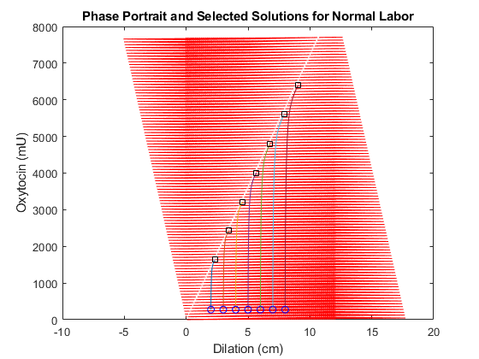

**Figure 2.** Phase Portrait for the model using normal spontaneous labor parameters. Selected solutions are plotted from 2 to 8 cm cervical dilation.